**Ritual to Establish the Current of the Henge**

**The Henge of the Cobbled Path**

September 3, 2017

**Almanac**

Sunset: 7:49 PM

End civil twilight: 8:14 PM

Moonrise 6:21 PM

Waxing Gibbous with 93% of the Moon's visible disk illuminated

**Setup**

* central fire that must not go out
* altar with statues and candles
* torches and citronella candles
* shrines for each of the Orkney stops
* bread and wine / mead / whiskey for offerings
* wine / mead / whiskey for travelers
* water for travelers
* the cloth is present in the circle
* chairs for all

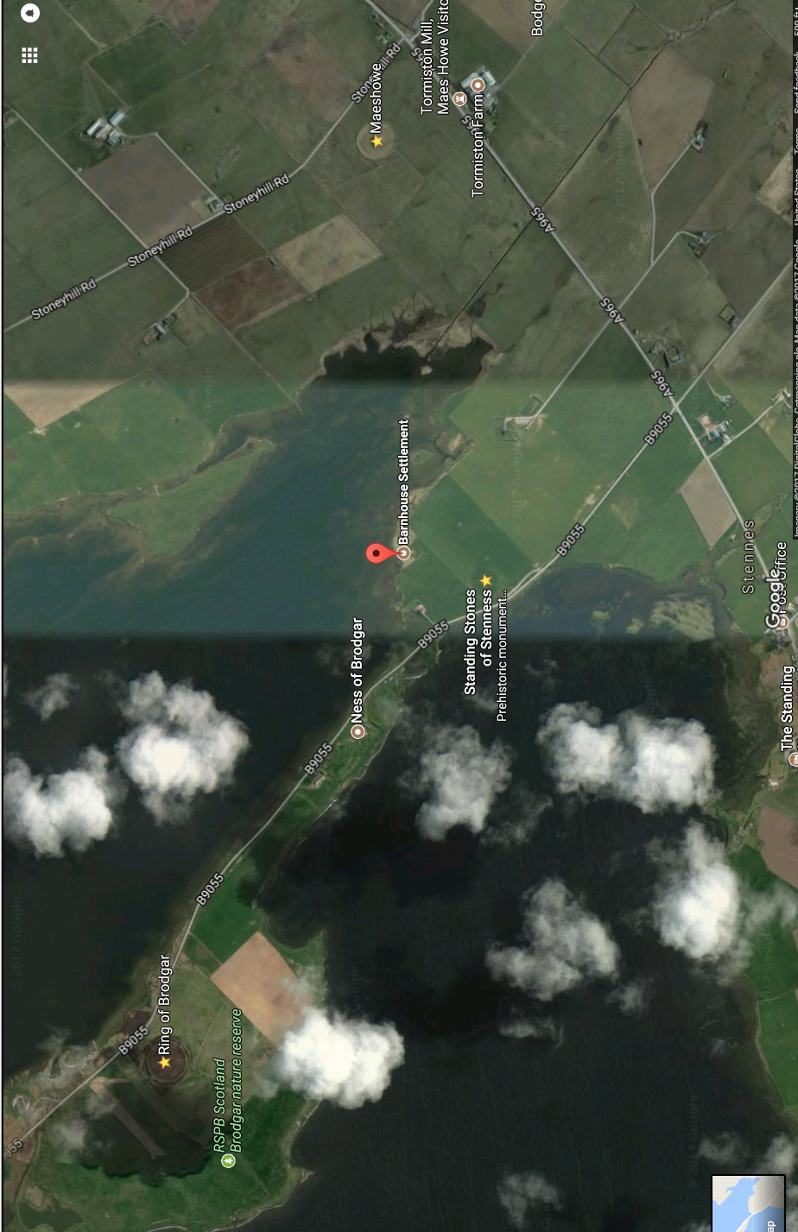

**Connections to the Past and Future**

“Bread, beer, and cloth bind us to those who came before and those who are yet to be:

Let bread nourish our bodies with the bounty of the harvest;

Let beer quench our thirst;

And let cloth shield us from storm and sun.”

Sharing of bread and beer, passing the cloth around

**The Initial Oath**

reminder of our oath of secrecy at the November ritual

**Set up Fire, Altar, Chairs**

If the weather is clear, set up in the back yard. If it is raining, or if there’s a good chance of rain, set up on the patio.

**Cleansing and Blessing**

Cast a wide outer circle, then make a pass around the yard with water, then with sage, then with incense

**Purification**

Each of us is cleansed with water, sage, and incense, then moves into the ritual area

**Lighting the Fire**

The fire is lit. The remaining water is poured on the ground at the base of the fire pit. The sage and incense are placed in the fire.

**Casting the Circle**

**Priest:** casts circle around the ritual area/yard.

**Calling the Quarters**

**Priest:** “Let us now invite the spirits of the directions and the elements to join our circle.”

**East Caller:** *light candle and say* “Spirits of the East, Spirits of Air, we call to you. Join this circle, we ask, and bless us with your wisdom. Teach us the ways of vision and judgment. Spirits of the East and of Air, hail and welcome!”

**All:** “Hail and welcome!”

**South Caller:** *light candle and say* “Spirits of the South, Spirits of Fire, we call to you. Join this circle, we ask, and bless us with your inspiration. Teach us the ways of creation and growth. Spirits of the South and of Fire, hail and welcome!”

**All:** “Hail and welcome!”

**West Caller:** *light candle and say* “Spirits of the West, Spirits of Water, we call to you. Join this circle, we ask, and bless us with your love. Teach us the ways of compassion and intuition. Spirits of the West and of Water, hail and welcome!”

**All:** “Hail and welcome!”

**North Caller:** *light candle and say* “Spirits of the North, Spirits of Earth, we call to you. Join this circle, we ask, and bless us with your abundance. Teach us the ways of patience and stability. Spirits of the North and of Earth, hail and welcome!”

**All:** “Hail and welcome!”

**Establishing the Center**

**Priest:** “This fire is for us the intersection of all times, all directions, and all worlds. We stand at the sacred center, and by this fire we part the veil between the worlds and step into the Otherworld, the world of the Gods and ancestors.

We make this offering, that our journeys may be safe and fruitful.”

**John, Cyn, and Hannah:** *Pour drink and crumble food into the fire*

**Invoking the Spirits of the Land**

**Priest of the Land Spirits:** *light candle and say* “Spirits of the Land, Spirits of this place; you who are unseen but felt, unnamed but present; you who were here long before us: we thank you for sharing this place with us. Tonight we ask for your protection and blessing on this sacred rite, that we may learn and grow in honor and in friendship.

Accept this offering, we ask, given in hospitality, and in love.”

*pour wine and crumble bread into fire*

“Spirits of this place! Hail and welcome!”

**All:** “Hail and welcome!”

**Invoking the Ancestors**

**Priest of the Ancestors:** *light candle and say* “Ancestors of blood and ancestors of spirit, those we knew in life and those who moved on before we were born, those whose names we know and those whose names we know not, you whose children we are and on whose foundations we build, because of you we have life. We ask that you support and guide us in our holy rite, that we may continue your lines in power and strength.

Accept this offering, we ask, given in hospitality, and in love.”

*pour wine and crumble bread into fire or offering bowl*

“Mighty ancestors! Hail and welcome!”

**All:** “Hail and welcome!”

**Invocation of Ancestral Allies**

**Priest:** “James Stevens, Royal Messenger, Protector, Builder of Community, and Ally of the Henge, we invite you to join our circle. We ask your assistance in this working, that our journeys may be swift and clear. We ask that foreknowledge be delivered to those we would visit.

Accept this offering, we ask, given in hospitality, and in love.”

*pour whiskey or beer and crumble bread into fire or offering bowl*

“James, hail and welcome!”

**All:** “Hail and welcome!”

**Priest:** “Vashti Woodring, Herald, Crafter, Dancer and Ally of the Henge, we invite you to join our circle. We ask your assistance in this working, that our journeys may be swift and clear. We ask that our arrival be foretold with courtesy.

Accept this offering, we ask, given in hospitality, and in love.”

*pour red wine and crumble bread into fire or offering bowl*

“Vashti, hail and welcome!”

**All:** “Hail and welcome!”

**Priest:** “Isaac Bonewits, Druid, Teacher, Author and Ally of the Henge, we invite you to join our circle. We ask your assistance in this working, that our journeys may be swift and clear, and our arrival done with all possible hospitality.

Accept this offering, we ask, given in hospitality, and in love.”

*pour whiskey and crumble bread into fire or offering bowl*

“Isaac, hail and welcome!”

**All:** “Hail and welcome!”

**Invocation of the Fae**

**Assisting Priest:** “Oh fairy folk of light and dark, you of the fae, you of the sídhe: we honor you tonight as our Good Neighbors. We are glad you share this place with us, and we enjoy the spark of otherworldliness you give our planet and our lives. We ask that you ward and bless this place, that our sacred work may be successful and uninterrupted.

Accept this offering, we ask, given in hospitality and in honor.”

*pour wine and crumble bread into fire or offering bowl*

“Hail and welcome!”

**All:** “Hail and welcome!”

**Invocation of Deities**

**Brighid:** *light candle and say* “Brighid, Goddess of Poetry, Lady of Healing, Goddess of Inspiration, of forging, and of music, we ask you to join our circle and bless us with your presence. Goddess of crafting, be welcome here. Inspire in us what we must be, we ask, so we can create what must become in the Great Work of this time and place.

Breed, Goddess of Smithcraft and Patron of Healers, hear us as we call to you. We thank you for inspiration, and for helping us better our crafting, whatever our arts or skills. For showing us that change need not be feared, we thank you.

Accept this offering, we ask, given in hospitality, and in love.”

*pour offering*

“Brigit, Brighid, Breed! Hail and welcome!”

**Morrigan:** *light candle and say* “Morrigan, Battle Raven, Lady of Sovereignty, we ask you to join our circle and bless us with your presence. You who gives the right to rule and who challenges us to rule rightly, be welcome here. Show us our strength, we ask, so we can uphold the Great Work of this time and place.

Morrigan, Queen of Phantoms, Chooser of the Slain, hear us as we call to you. We thank you for your inspiration to stand against those who would rule our lives for their own ends, and to stand against injustice everywhere. Great Queen, let us fight by your side until peace is won.”

Accept this offering, we ask, given in hospitality, and in love.”

*pour offering*

“Morrigan! Hail and welcome!”

**Neteru:**  *light candle and say* “Mighty Neteru, Gods of Egypt, join our rite, we ask, and bless us with your presence. Auset, Tehuti, Anpu, we call your names in honor, and give honor to all the Gods of Upper and Lower Egypt who we know and to those we know not, but who know us.

Grant us your grace, we ask, as we do what must be done to establish the ways of Ma’at in our lives and in our land.”

*pour offering*

“Mighty Neteru! Hail and welcome!”

**Lugh:** *light candle and say* “Lugh Lámhfhada, Lugh of the Long Arm, we ask you to join our circle and bless us with your presence. Great Champion and King, Slayer of Balor, be welcome here. Grant us the gift of your invincible spear, we ask, that we may be victorious in our fight to protect our community, our world, and all the creatures who share it with us.

Lugh Samildánach, Master of All Arts, hear us as we call to you. We thank you for the many skills represented here in our midst. Teach us what we must learn, we ask, so we can join you in the Great Work of this time and place.”

Accept this offering, we ask, given in hospitality, and in love.”

*pour offering*

“Lugh! Hail and welcome!”

**Danu:** *light candle and say* “Danu, Mother Goddess and Lady of the Waters, Mother of the Earth and Mother of us all, we ask you to join our circle and bless us with your presence. Giver of Life, be welcome here. Create in us what we must be, so we can create what must become in the Great Work of this time and place.

Danu, Goddess of Nature and Mother to our tribe, hear us as we call to you. We thank you for the waters: for the streams and lakes from which we drink, for the rains which replenish and rejuvenate the land, and for the seas from which all life emerged.

Accept this offering, we ask, given in hospitality, and in love.”

*pour offering*

“Danu! Hail and welcome!”

**Cernunnos:** *light candle and say* “Cernunnos, Lord of the Animals and Lord of the Hunt, God of the Forest and of Green Growing Things, we ask you to join our circle and bless us with your presence. Great Hunter and Hunted, be welcome here. Teach us what we must learn, so we can join you in the Great Work of this time and place.

Cernunnos, Horned God, God of Nature and Father to our tribe, hear us as we call to you. We thank you for the animals: those that nourish our bodies, those that bring signs and omens, those that inspire us with their beauty and power, and those that accompany us through life. Hunter and Hunted, let us run with you through the forest; teach us again to be wild and free.”

Accept this offering, we ask, given in hospitality, and in love.”

*pour offering*

“Cernunnos! Hail and welcome!”

**Cerridwen:** *light candle and say* “Hail Cerridwen, Lady of the Cauldron. Lady who brews wisdom, magic, inspiration. Keeper of mysteries, who has worn many shapes, many faces, many feet. May we learn the secret of perspective, that knowledge and learning are ever-changing, that by being in other's skins, we are never tied to our own rigid views of the world. Cerridwen, White Lady, lead us to the cauldron of transformation.

Cerridwen, Lady of Magic, hear us as we call to you. We thank you for the gift of knowledge, The gift of Awen- and the three rays of light. Lady, of divination, Mother of Morfran, Creinwy, and Taliesin, we welcome you to our circle.”

Accept this offering, we ask, given in hospitality, and in love.”

*pour offering*

“Cerridwen! Hail and welcome!”

**Invocation of Associated Deities**

“Gods not of the Henge but who we follow as individuals: we welcome you to our circle. We offer you hospitality, and we invite you to observe our rites.”

*pour offering*

Gods on the “wait and see” list may be invoked and honored by name.

**The Main Working**

**Priest:** “Keep solemn silence. Keep solemn silence. We pray to the Gods, for here we begin the Mysteries. I speak to those who lawfully may hear: depart, all who are profane, and close the gates. If your hands are impure or your heart is unclean, I charge you once, I charge you twice, I charge you thrice to stay away from this sacred dance. Let all who honor the Gods perform the Mysteries. O great Gods, make us worthy to celebrate your Mysteries.”

**Travelers** (John, Cyn, Hannah) sit for long enough to go into a light trance and to be in this world and in the Otherworld at the same time. Pass around some mead if it is needed.

When all appear to be ready, **Guide** softly asks all three if they’re ready.

When **Travelers** are ready to depart, one takes the basket with a loaf of bread, the wine and the cloth. One takes the the mead and the firewood, and the third takes cauldron/bucket. Travelers need to be “ready to travel” and then walk to Maes Howe/Shrine.

When all are ready, help the travelers up and lead them to the Maes Howe shrine.

We need a cord or rope or something to keep the three travelers together here and there.

**Maes Howe**

There are skulls and bones waiting on the shrine table. At the Maes Howe shrine, the **Travelers** pour offerings to our collective ancestors, pouring in both this world and in the Otherworld. Whoever has the basket sets a piece of wood on the Shrine table.(There should be a fire in the square fire pit that was once a part of the site burning there in the other world. We need to put a new piece of wood on the fire and take a coal and take it with us.

Guide should pour in this world if the Travelers don't.

There may be visions, messages, or something else, or not.

When everything is complete, the Travelers put a piece of wood on the fire in the Otherworld and take a coal from it for the Cauldron of Fire.

When this step is complete, **Guide** leads the travelers to the Stenness shrine.

**Stenness**

At the Stenness shrine, the **Travelers** pour offerings (again, in this world and in the Other Orkney) to the Gods, the Fae, the spirits of Place and the spirits of Nature - all our non-ancestral spiritual allies. We will have already invoked and offered to them individually in the preliminary ritual. I expect this will be brief and collective – one offering to each of the four groups, plus a fifth for those “in between.”

The more I do this the more I’m convinced all these beings exist on a spectrum, not in distinct classifications. But I haven’t figured out how to pour offerings to a spectrum yet, so this is the best I’ve got.

There may be visions, messages, or something else, or not.

We need to add wood to the fire there too. So a piece goes on the shrine table in the real world. And take another coal with us in our cauldron.

When everything is complete, the Travelers put a piece of wood on the fire in the Otherworld and take a coal from it for the Cauldron of Fire.

When this step is complete, **Guide** leads the travelers to theBarnhouse Shrine.

**Barnhouse**

At the Barnhouse shrine, , there is honey, and meadowsweet, and a tankard/drinking horn. The **Travelers** offer honey and meadowsweet to the mead that is brewing in the Otherworld.

The **Travelers** take an oath to serve the Henge, its mission, its members, and those the Gods send to us. This is the line in the sand, the binding commitment that none of us have made yet (we have only taken an oath of confidentiality).

Other members will take this oath as they do their own current-connection ritual (the first one is September 30)

**Priest:** “You stand before a line that once crossed cannot be uncrossed. What you are about to swear cannot be unsworn. Do you understand the severity of this act?”

**Travelers:** answer in the affirmative

**Priest:** “Will you serve the Henge of the Cobbled Path?”

**Travelers:** answer in the affirmative

**Priest:** “Will you support its mission and its members?”

**Travelers:** answer in the affirmative

**Priest:** “Will you guide, teach, and train those who are sent to us to the best of your ability, mindful of your own limitations, and with proper discernment for the suitability of candidates for the Mysteries?

**Travelers:** answer in the affirmative

**Priest:** “Then so swear, by the Land, by the Gods who have called you, and by the honor of your heart and soul.”

**Travelers:** “This I swear, by the Land, by _________, and by the honor of my heart and soul.”

**Priest:** “The oath is made.”

**All other participants:** “The oath is witnessed.”

When everything is complete, the Travelers put a piece of wood on the fire in the Otherworld and take a coal from it for the Cauldron of Fire.

When this step is complete, **Guide** leads the travelers across the spar to the Ness of Brodgar

**Ness of Brodgar**

On the shrine is a bowl of water.

I have no idea what happens here. Maybe nothing, maybe something small, maybe something really important.

“between the wind and the water”

We need to get some of the water to take with us, and maybe some seafoam and sand.... The land between the wind and the water.. It goes in the cauldron, with the coals.

When this step is complete, **Guide** leads the travelers to the Ring of Brodgar shrine.

**Ring of Brodgar**

On the shrine is the stick from the ring.

We go up the hill to the entrance to the Ring of Brodgar. We will be met by the Guardian of the Ring.

We make two offerings: a bottle of wine, and a bottle of mead with meadowsweet. We offer friendship (hospitality and reciprocity).

We ask to be admitted to the (decidedly limited) greater gathering of henge builders, past and present.

We introduce ourselves to the henge building/corbeled vault tomb/temple building gathering.

We have come from over the ocean that way, west of Erine, but we are building our own tribal henge there.

We have brought mead, and bread.

Can we please join you tonight for drink, bread, and stories? So that we may learn to do what we would do better from those who have already done so?

That's why the wine is important. I think it needs to be Texas wine. The Mead needs to be Texas mead (we're brewing it ourselves so yes) we might want to mingle our whiskey actually, some Irish, some Welsh, some Scots, and some Texas.

The bread needs to be homemade, as much as possible. With Texas ingredients. I have what we need, but I would like to bake it at your house John, since that's where the ritual will be.

That feels right to me.

We need to have the cloth with us here and there, I don't know why

At this point, I don't know what happens.

We need chairs here, this is going to take a while. Sit, drink, talk, listen.

If all goes well, we will be given or allowed to collect fire from the Otherworldly Ring of Brodgar. (This needs to actual flaming sticks not just coals. Also we need to add wood back to the fire there. This should be the last of what we brought with us, and the best of it.

Ash-logs, smooth and grey,

Burn them green or old

Buy up all that come your way

Worth their weight in gold.

We can go sit around the fire if we are invited in, in both worlds.

I’m expecting to be here a while, but I really have no idea.

I go back to what I said in the beginning, we need to join in the gathering, learn what we can and listen.

**Travelers** still need to keep one foot in both worlds until the ritual is complete.

**Completing the Current**

**Travelers** ritually pour the Cauldron of Fire into the Central Fire. This establishes the Current of the Henge.

**Connecting to the Current**

**Travelers** light tallow candles from the Central Fire. Drip a small amount of tallow onto bread and eat it. This – along with the oath and the experience of the journey – connects the individuals to the current.

**Guide:** “Is the Current established and flowing?”

All three Travelers should agree that it’s done.

At this point the Travelers should fully return to the ordinary world. If one or more is unable, give them time. If it looks like there are problems, start working to bring them back, one at a time.

When everyone is back, begin the Devocation.

**Devocation**

“Gods not of the Henge but who we follow as individuals; Cerridwen, Cernunnos, Danu, Lugh, all the Neteru, Morrigan, Brighid. May there be peace and honor between us now and forever. Hail and farewell!”

“Mighty sídhe: Seelie, unseelie, and wild, we thank you for your presence and your inspiration. May there be peace and honor between us now and forever. Hail and farewell!”

“Ancestral Allies of the Henge: James, Vashti, and Isaac, we thank you for your presence and your assistance. May our connections strengthen as our work continues across the Veil. Hail and farewell!”

“Mighty Ancestors, we thank you for your presence and your wisdom. May our time together renew and strengthen our connections across many generations and many realms of existence. Hail and farewell!”

“Spirits of this place, we thank you for your presence and your blessings. May there be peace and honor between us now and forever. Hail and farewell!”

“Spirits of the North, Spirits of Earth; Spirits of the West, Spirits of Water; Spirits of the South, Spirits of Fire; Spirits of the East, Spirits of Air; we thank you for your presence and your blessings. May there be peace and honor between us now and forever. Hail and farewell.”

Uncast the circle

**Discussion and Interpretation**

eat, drink, get warm / cool / dry

everyone discusses what they heard / saw / felt, in this world and in the Otherworld

Scribe continues writing

discuss interpretations, meanings, and implications