The Feast of Danu

Next Thursday, June 29, is the first celebratory date on the liturgical calendar of the Henge of the Cobbled Path – the Feast of the Goddess Danu. I find it appropriate that although Danu has had a relatively small part in the establishment of the Henge, it is the Mother of the Tuatha De Danann we honor first.
It is our obligation as members of the Henge to honor our patron deities and allied ancestors on their days. Most times we will do this individually – occasionally we will do it together.
This is a model ritual you can use to fulfill this obligation. You do not have to do this ritual – you are free to honor and celebrate Danu in whatever way seems appropriate to you. But please keep this festival in some way or another, even if all you do is call her name and pour an offering of clean water.
Danu
Danu is a very old Goddess and like many old, primal deities there are few stories about her. I haven’t found any that say anything more than listing her as the mother of the Tuatha De Danann – the Children of the Goddess Danu. Most of what we know about her history comes from etymological studies: her name is connected to several rivers in central Europe, most notably the Danube.
Danu is associated with the Irish Anu and Danann and the Welsh Don. There is a Danu in the Hindu Rig-Veda – I’ve read arguments both for and against connecting her to the Celtic Danu. Given the age of the Rig-Veda and the general migration of Indo-European peoples, it’s a plausible connection.
In a 1998 essay, Celticist Alexi Kondratiev argued that the idea of Danu as the mother of the gods of Ireland is a fairly recent concept. He went on to say:
The association of Danann with a probably much older figure named ‘Anann’ or ‘Anna’ also suggests that she may have been superimposed on a goddess with more primeval “Mother Earth” traits.
Are these different names for the same goddess or different goddesses who do similar things in different places and times? I don’t know and I’m not sure we can know.
I see Danu as a mother goddess because that’s how I’ve experienced her. Like the rivers that bear her name, she brings life to the land and the people. Also like the rivers, she demands respect.
She is a patient and loving mother, but she is not a divine helicopter parent. There have been more than a few times when I’ve heard/felt her say “it’s OK, you’re still loved. Now what are you going to do to clean up this mess you made?” She’s not unconcerned with my feelings, but she’s more concerned that I grow up and be who and what I’m meant to be.
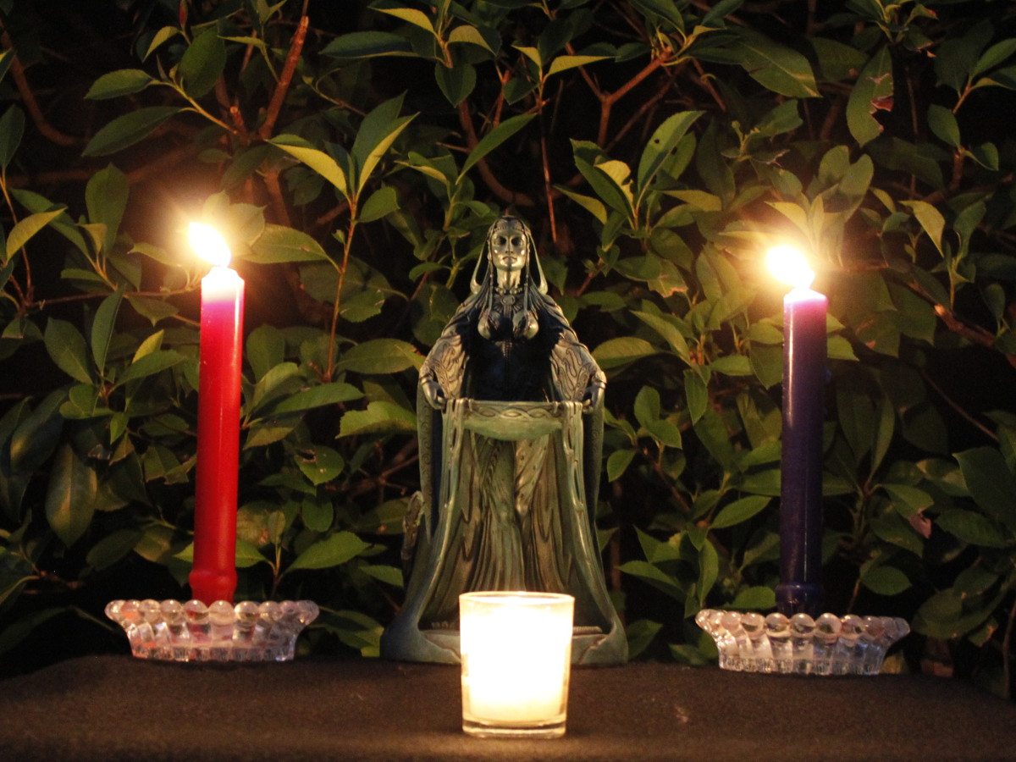
The Ritual
Prepare yourself for ritual. Take a few deep breaths, ground and center. Perform an act of purification – dip your fingers in water, then touch the water to your forehead, your chest, and your other hand.
Light a candle and say “Danu, Mother Goddess and Lady of the Waters, Mother of the Earth and Mother of us all, I ask you to join this circle and bless us with your presence. Giver of Life, be welcome here. Create in us what we must be, so we can create what must become in the Great Work of this time and place.
Danu, Goddess of Nature and Mother to our tribe, hear us as we call to you. I thank you for the waters: for the streams and lakes from which we drink, for the rains which replenish and rejuvenate the land, and for the seas from which all life emerged.
Accept this offering, I ask, given in hospitality, and in love.”
Pour an offering of clean water.
“Danu! Hail and welcome!”
Now sit or stand quietly and wait for her presence.
Listen.
Hear.
Respond as you feel moved.
When you feel the communion is over, pour another offering, and this time drink some yourself.
Listen.
When it is over, extinguish the candle and say “Danu, Mother Goddess and Lady of the Waters, I thank you for your presence and your blessings. May we always honor you in freedom and power. Hail and farewell!”
Gradually bring yourself back to this place, this time, and this world.
Make notes of anything that struck you as significant, whether you feel moved to share them with the rest of the Henge or if you simply keep them for yourself.
Next Festival
Our next liturgical festival is the Feast of Lugh on Tuesday, August 1, followed shortly by the Feast of the Neteru on Friday, August 4 (begins at sunrise).

