**Ritual to Re-establish the Current of the Henge**

**The Henge of the Cobbled Path**

August 28, 2021

**Almanac**

Sunset: 7:56 PM

End civil twilight: 8:21 PM

Moonrise 11:36 PM

Waning Gibbous with 67% of the Moon's visible disk illuminated

**Setup**

* central fire that must not go out
* altar with statues and candles
* torches and citronella candles
* shrines for each of the Orkney stops
* bread and wine / mead / whiskey for offerings
* wine / mead / whiskey for travelers
* water for travelers
* the cloth is present in the circle
* chairs for all

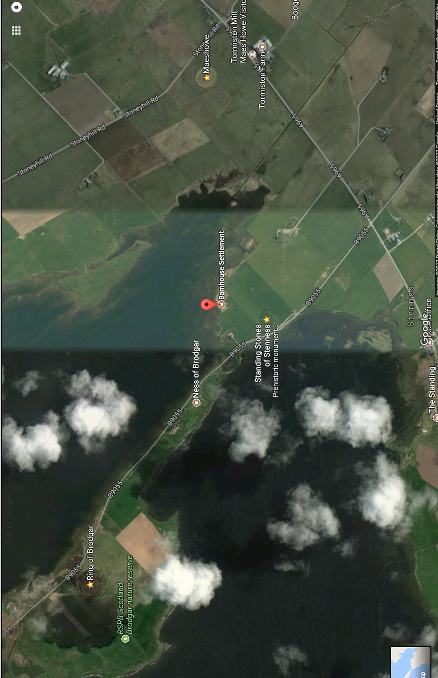

**Lighting the Fire**

Light the fire before we begin

**Cleansing**

Everyone cleanses themselves with water.

**Connections to the Past and Future**

“Bread, beer, and cloth bind us to those who came before and those who are yet to be:

Let bread nourish our bodies with the bounty of the harvest;

Let beer quench our thirst;

And let cloth shield us from storm and sun.”

Sharing of bread and beer, passing the cloth around

**The Initial Oath**

reminder of our oath of secrecy

**Procession**

Everyone moves into the ritual area

**Formal Opening**

**Priest:** *ring bell three times*

“We gather as the Henge of the Cobbled Path, as many individuals who form one order. We are here tonight to seek guidance from our Gods and other spiritual allies, and to re-establish the spiritual current which we began in good faith, but have been unable to fully transmit.

May our work tonight be blessed.”

**Calling the Quarters**

**Priest:** “Let us now invite the spirits of the directions and the elements to join our circle.”

**East Caller:** “Spirits of the East, Spirits of Air, we call to you. Join this circle, we ask, and bless us with your wisdom. Teach us the ways of vision and judgment. Spirits of the East and of Air, hail and welcome!”

**All:** “Hail and welcome!”

**South Caller:** “Spirits of the South, Spirits of Fire, we call to you. Join this circle, we ask, and bless us with your inspiration. Teach us the ways of creation and growth. Spirits of the South and of Fire, hail and welcome!”

**All:** “Hail and welcome!”

**West Caller:** “Spirits of the West, Spirits of Water, we call to you. Join this circle, we ask, and bless us with your love. Teach us the ways of compassion and intuition. Spirits of the West and of Water, hail and welcome!”

**All:** “Hail and welcome!”

**North Caller:** “Spirits of the North, Spirits of Earth, we call to you. Join this circle, we ask, and bless us with your abundance. Teach us the ways of patience and stability. Spirits of the North and of Earth, hail and welcome!”

**All:** “Hail and welcome!”

**Establishing the Center**

**Priest:** “This fire is for us the intersection of all times, all directions, and all worlds. We stand at the sacred center, and by this fire we part the veil between the worlds and step into the Otherworld, the world of the Gods and ancestors.

We make this offering, that our journeys may be safe and fruitful.”

*Pour whiskey into the fire*

**Invoking the Spirits of the Land**

**Priest of the Land Spirits:** “Spirits of the Land, Spirits of this place; you who are unseen but felt, unnamed but present; you who were here long before us: we thank you for sharing this place with us. Tonight we ask for your protection and blessing on this sacred rite, that we may learn and grow in honor and in friendship.

Accept this offering, we ask, given in hospitality, and in love.”

*Pour whiskey into the fire*

“Spirits of this place! Hail and welcome!”

**All:** “Hail and welcome!”

**Invoking the Ancestors**

**Priest of the Ancestors:** “Ancestors of blood and ancestors of spirit, those we knew in life and those who moved on before we were born, those whose names we know and those whose names we know not, you whose children we are and on whose foundations we build, because of you we have life. We ask that you support and guide us in our holy rite, that we may continue your lines in power and strength.

Accept this offering, we ask, given in hospitality, and in love.”

*Pour whiskey into the fire*

“Mighty ancestors! Hail and welcome!”

**All:** “Hail and welcome!”

**Invocation of Ancestral Allies**

**Priest:** “Ancestral Allies of the Henge: James Stevens, Royal Messenger; Vashti Woodring, Herald; we invite you to join our circle. We ask your assistance in this working, that our journeys may be swift and clear.

*Pour whiskey into the fire, red wine for Vashti*

“James, Vashti, hail and welcome!”

**All:** “Hail and welcome!”

**Invocation of the Fae**

**Assisting Priest:** “Oh fairy folk of light and dark, you of the fae, you of the sídhe: we honor you tonight as our Good Neighbors. We are glad you share this place with us, and we enjoy the spark of otherworldliness you give our planet and our lives. We ask that you ward and bless this place, that our sacred work may be successful and uninterrupted.

Accept this offering, we ask, given in hospitality and in honor.”

*pour offering*

“Hail and welcome!”

**All:** “Hail and welcome!”

**Invocation of Deities**

**Brighid:** “Brighid, Goddess of Poetry, Lady of Healing, Goddess of Inspiration, of forging, and of music, we ask you to join our circle and bless us with your presence. Goddess of crafting, be welcome here. Inspire in us what we must be, we ask, so we can create what must become in the Great Work of this time and place.

Accept this offering, we ask, given in hospitality, and in love.”

*pour offering*

“Brigit, Brighid, Breed! Hail and welcome!”

**Morrigan:** “Morrigan, Battle Raven, Lady of Sovereignty, we ask you to join our circle and bless us with your presence. You who gives the right to rule and who challenges us to rule rightly, be welcome here. Show us our strength, we ask, so we can uphold the Great Work of this time and place.

Accept this offering, we ask, given in hospitality, and in love.”

*pour offering*

“Morrigan! Hail and welcome!”

**Neteru:**  “Mighty Neteru, Gods of Egypt, join our rite, we ask, and bless us with your presence. Auset, Tehuti, Anpu, we call your names in honor, and give honor to all the Gods of Upper and Lower Egypt who we know and to those we know not, but who know us.

Grant us your grace, we ask, as we do what must be done to establish the ways of Ma’at in our lives and in our land.”

*pour offering of beer*

“Mighty Neteru! Hail and welcome!”

**Lugh:** *light candle and say* “Lugh Lámhfhada, Lugh Samildánach, we ask you to join our circle and bless us with your presence. Great Champion and King, Slayer of Balor, be welcome here. Grant us the gift of your invincible spear, we ask, that we may be victorious in our fight to protect our community, our world, and all the creatures who share it with us.

*pour offering*

“Lugh! Hail and welcome!”

**Danu:** *light candle and say* “Danu, Mother Goddess and Lady of the Waters, Mother of the Earth and Mother of us all, we ask you to join our circle and bless us with your presence. Giver of Life, be welcome here. Create in us what we must be, so we can create what must become in the Great Work of this time and place.

Accept this offering, we ask, given in hospitality, and in love.”

*pour offering*

“Danu! Hail and welcome!”

**Cernunnos:** *light candle and say* “Cernunnos, Lord of the Animals and Lord of the Hunt, God of the Forest and of Green Growing Things, we ask you to join our circle and bless us with your presence. Great Hunter and Hunted, be welcome here. Teach us what we must learn, so we can join you in the Great Work of this time and place.

Accept this offering, we ask, given in hospitality, and in love.”

*pour offering*

“Cernunnos! Hail and welcome!”

**Cerridwen:** *light candle and say* “Hail Cerridwen, Lady of the Cauldron. Lady who brews wisdom, magic, inspiration. Keeper of mysteries, who has worn many shapes, many faces, many feet. May we learn the secret of perspective, that knowledge and learning are ever-changing, that by being in other's skins, we are never tied to our own rigid views of the world. Cerridwen, White Lady, lead us to the cauldron of transformation.

Accept this offering, we ask, given in hospitality, and in love.”

*pour offering*

“Cerridwen! Hail and welcome!”

**Invocation of Associated Deities**

“Gods not of the Henge but who we follow as individuals: we welcome you to our circle. We offer you hospitality, and we invite you to observe our rites.”

*pour offering*

Other Gods may be invoked and honored by name.

**The Main Working – The Forge**

**Priest:** “Keep solemn silence. Keep solemn silence. We pray to the Gods, for here we begin the Mysteries. I speak to those who lawfully may hear: depart, all who are profane, and close the gates. If your hands are impure or your heart is unclean, I charge you once, I charge you twice, I charge you thrice to stay away from this sacred dance. Let all who honor the Gods perform the Mysteries. O great Gods, make us worthy to celebrate your Mysteries.”

**Travelers** (John, Cyn) sit and move toward the Forge.

Write down anything and everything.

If John and Cyn come back, take a brief break before moving into re-establishing the current. If not, go directly there.

**The Main Working – Re-establishing the Current**

Lead John and Cyn to the shrines, in order

travel with bread, beer, and cloth

mead

**1. Maes Howe**

pour offerings to ancestors – mead and bread

**2. Stenness**

note from 2017: Hannah: “The stone is breathing.” John: “It’s alive.”

pour offerings to the Gods, the Fae, the spirits of Place and the spirits of Nature - all our non-ancestral spiritual allies. – mead and bread

**3. Barnhouse**

note from 2017: the mead tenders who weren’t there. “We were supposed to be here a year ago.”

pour offerings of mead and honey to the community of Henge builders

**4. Ness of Brodgar**

note from 2017: a spirit tried to interrupt the ritual. William blocked it and sent it away.

pour offerings to the spirits of the place, between the wind and the water

**5. Ring of Brodgar**

bring offerings of hospitality: bread and wine and mead

separate bottle

when all is done

**Devocation**

“Gods not of the Henge but who we follow as individuals; Cerridwen, Cernunnos, Danu, Lugh, all the Neteru, Morrigan, Brighid. May there be peace and honor between us now and forever. Hail and farewell!”

“Mighty sídhe: Seelie, unseelie, and wild, we thank you for your presence and your inspiration. May there be peace and honor between us now and forever. Hail and farewell!”

“Ancestral Allies of the Henge: Vashti and James, we thank you for your presence and your assistance. May our connections strengthen as our work continues across the Veil. Hail and farewell!”

“Mighty Ancestors, we thank you for your presence and your wisdom. May our time together renew and strengthen our connections across many generations and many realms of existence. Hail and farewell!”

“Spirits of this place, we thank you for your presence and your blessings. May there be peace and honor between us now and forever. Hail and farewell!”

“Spirits of the North, Spirits of Earth; Spirits of the West, Spirits of Water; Spirits of the South, Spirits of Fire; Spirits of the East, Spirits of Air; we thank you for your presence and your blessings. May there be peace and honor between us now and forever. Hail and farewell.”

**Discussion and Interpretation**

eat, drink, get warm / cool / dry

everyone discusses what they heard / saw / felt, in this world and in the Otherworld

Scribe continues writing

discuss interpretations, meanings, and implications