There are five steps on the journey to reach the current of the Henge. They align with five real places in Orkney. Cyn and I visited four of them (the fifth wasn’t open to visitors) on our trip there in 2016 and we were struck with the significance of them. In our Henge work, we visit their Otherworldly correspondences, which are the same as the ones in this world, except they’re Otherworldly so they’re different. I think you all know what I mean.

The weather was beautiful the day before – the day we made this journey it was 35 degrees with high winds and sleet. That day felt very much like an ordeal, in every sense of the word.

**1. Maeshowe**

We begin – as we did in 2016 – at Maeshowe. For us it is a place of the ancestors. It’s a chambered tomb that dates to around 2700 BCE. It’s been used by different people at different times, including the Vikings.

<http://www.orkneyjar.com/history/maeshowe/index.html>

Photography is not permitted inside – here’s a picture off the internet.

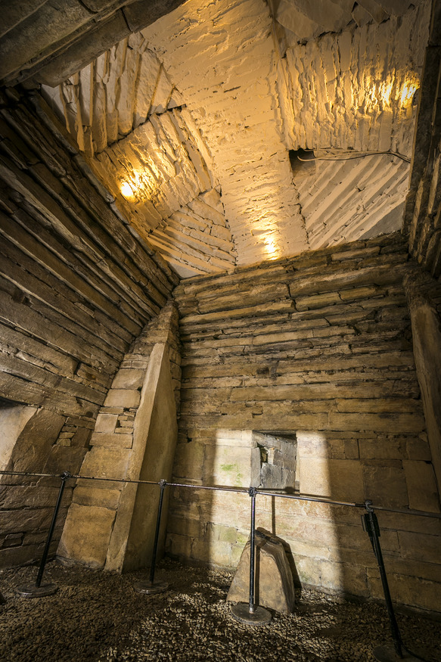

**2. The Standing Stones of Stenness**

Stenness is a stone circle (or rather, what’s left of a stone circle). For us it is a place of the Othercrowd – the Fair Folk, the spirits of place and of Nature. It dates to around 3100 BCE, making it one of if not the oldest stone circle in Britain.

<http://www.orkneyjar.com/history/standingstones/>

**3. Barnhouse Settlement**

Barnhouse Settlement was a place where people lived – perhaps the priests who tended the stone circles and the chambered tombs. For us it is a place of community and hospitality.

<http://www.orkneyjar.com/history/barnhouse/>

This wasn’t on our original itinerary. We wouldn’t have gone here if Cyn hadn’t insisted on it – and if she hadn’t found the path that leads there from Stenness.

**4. The Ness of Brodgar**

The Ness of Brodgar is still being excavated – we weren’t able to visit it. It dates to around 3300 BCE and may have been a temple. For us it is a place of transition: “between the wind and the water.”

<https://www.nessofbrodgar.co.uk/>

**5. The Ring of Brodgar**

The Ring of Brodgar is the 3rd largest stone circle in Britain, behind only Avebury and Stanton Drew. It dates to around 2500 BCE, making it the youngest structure in the area. For us it is the terminal point on the journey.

<http://www.orkneyjar.com/history/brodgar/>

It’s built on the side of a sloping hill. You walk up a brief incline to enter the circle, and the circle itself is on an inclined plane.

By the time we got there the weather was simply horrid. Two other people who were part of the group that led to the Henge were on this trip – they took a quick look and went back to the car. They eventually chose not to be part of the Henge.

I made three complete passes around the circle – Cyn joined me for the final one where we were told to go back to Texas and build what needed to be built.

Cathy stayed and held our packs while we doing this.

This is a big place – I needed a wide angle lens.

On Saturday, we will make this journey again. At each stop we will make offerings, and we will listen. And by the time we enter the Ring of Brodgar (assuming we’re allowed to enter, which I think will happen but isn’t guaranteed) we hope to have the knowledge and skills we need to re-establish the Current of the Henge of the Cobbled Path.